

**Assessment Cover Page**

**Declaration**

By submitting this assessment, I confirm that I have read the CCT policy on academic misconduct and understand the implications of submitting work that is not my own or does not appropriately reference material taken from a third party or other source.

I declare it to be my own work and that all material from third parties has been appropriately referenced.

I further confirm that this work has not previously been submitted for assessment by myself or someone else in CCT College Dublin or any other higher education institution.

|  |  |
| --- | --- |
| *Student Full Name* Jason Liu Doyle |  |
| *Student Number* 2024200 |  |
| Module Title  *Machine Learning* |  |
| *Assessment Title*  Integrated CA2 |  |
| *Assessment Due Date 26/05/2024* |  |
| *Date of Submission*  *24/05/2024* |  |

Table of Contents

Introduction to report and objectives 3

Data Prep 3

Characterisation 3

Clean and Prep 4

EDA 5

Encoding and Scaling 14

Dimension Reduction 15

Stats 900 18

Statistical Summary 18

Tests 19

Correlation Analysis 24

Machine Learning 25

Introduction 25

Supervised 26

Unsupervised 30

Conclusion and Key Findings 32

References 33

# Introduction to report and objectives

Throughout this report I will try and answer two hypothetical objectives;

* Predict the presence of Disease A,B,C or none in a patient based off of the given features
* Create patient segments for further analyse

This report will be split into three sections; Data preparation, Statistical Analysis and Machine Learning.

In the data preparation section I will characterise the data, clean and prep the data and conduct EDA on the data. I will address the encoding and scaling I did throughout the report here too. I will also address Sections 5.1 and 5.2 in the notebook where I employed PCA and LDA and compare the two in detail.

In my Statistical Techniquessection I will give a statistical summary of the data as well as three statistical visualisations. I will conduct hypothesis tests and conduct correlation analysis.

In my Machine Learning Section I will go through my model selection process, hyper parameter tuning, and cross validation for my supervised models. I will also walk you through my unsupervised clustering model.

# Data Prep

## Characterisation

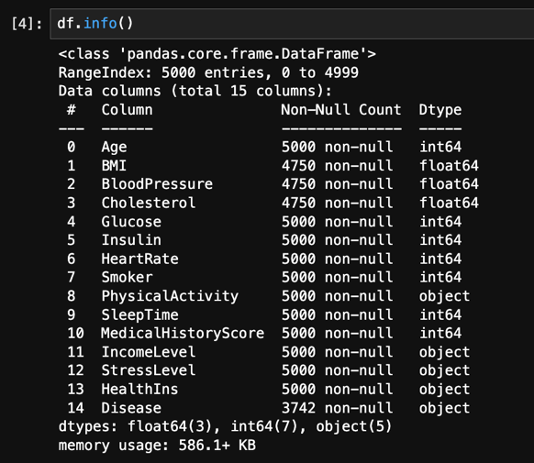

*Figure 1 Dataset information*

As you can see fig1.0 Our data set is pretty small. It only uses 586.1KB in memory usage, has 5000 samples and 15 features, which should not be a problem for my computer to handle. There is a mixture of 7 integers, 3 floating numbers and 5 object datatypes, our target variable ‘Disease’ being one of them. Our dataset has 3 features with Null data, BMI, Blood Pressure and Cholesterol. Our target ‘Disease’ feature also has null counts but as stated in the data dictionary, these are ‘none’ or ‘no disease present’.

## Clean and Prep

I began by renaming my features with the snake convention (fig2) (Leino, 2016) .

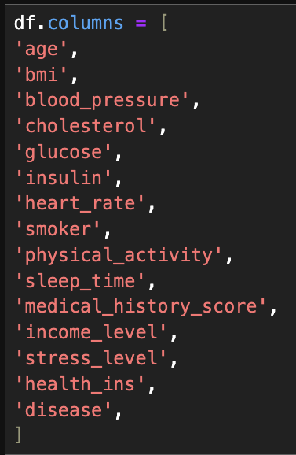

*Figure 2 Renaming with Snake Convention*

I then checked for any null data in the features, and what percentage of the total rows are null (fig3). As the missing data in the Disease column is most likely our ‘none’ category from the data dictionary, I fill all missing values in that row with “No_Disease”. For the other three, I initially chose to impute the median but changed that to backfill in later commits, as doing the former affected the distribution too much.

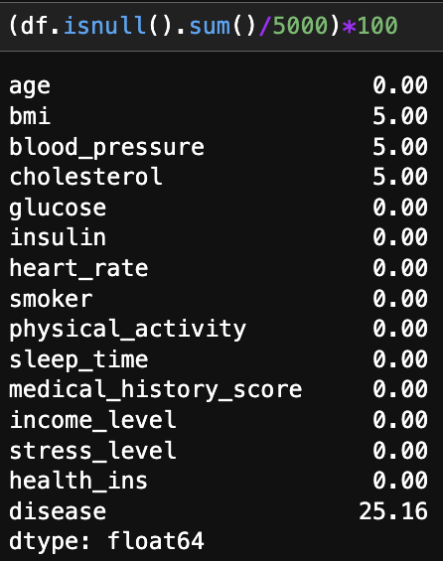

Figure 3 Null data as a percentage

I checked for duplicates and found none. I then chose to split my data by datatype, into categorical features and numerical features, this is for later EDA. With all the data cleaned and prepared I created a copy of the data which may come in handy later on (df_borrow).

## EDA

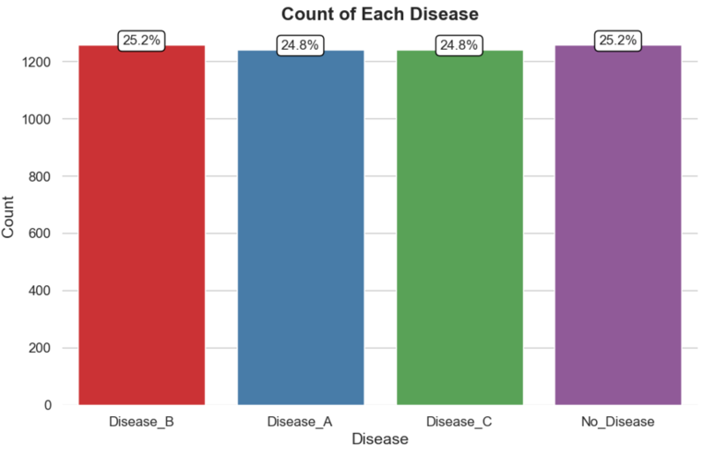

*Figure 4 Distribution of Disease Categories*

Our Disease Categories are very well balanced, with a deviation of less than a percent between them (*fig4*).

I split the rest of this section in two, my numerical features and my categorical ones. I’ll start off with my numerical features.

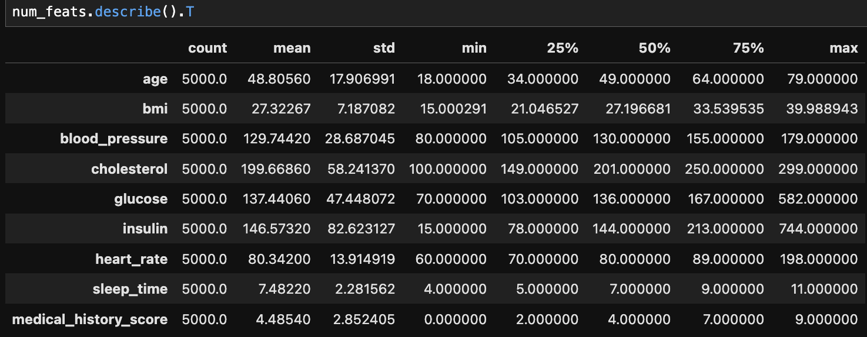*Figure 5 Description of statistics of numerical features*

We can see some skewed data and some heavy outliers in figure 5. So I decided to explore the distribution with some more in depth visuals, and their findings underneath

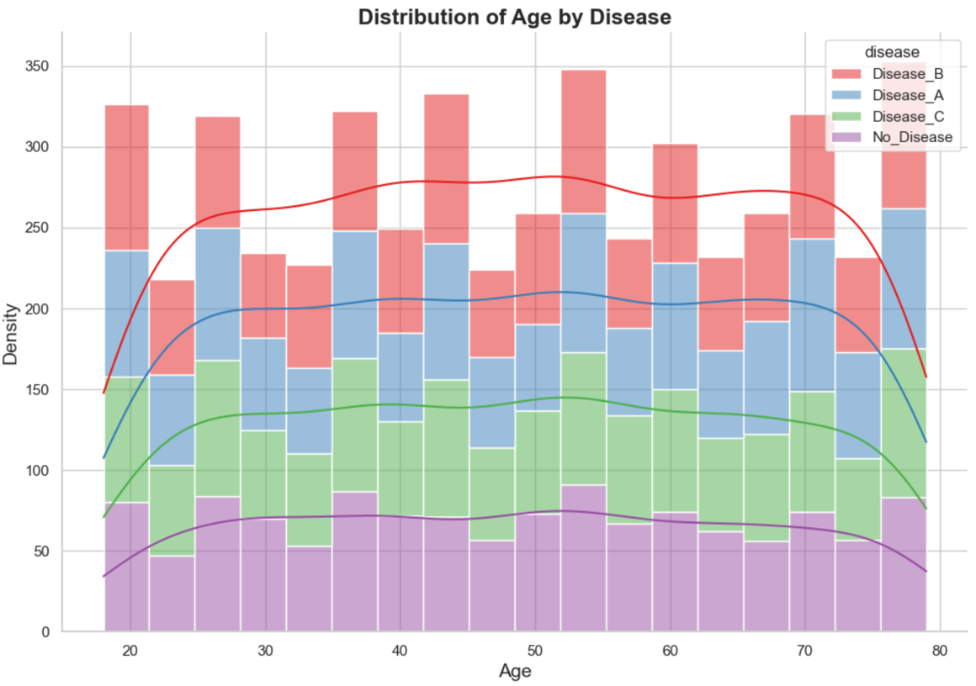

*Figure 6 Distribution of Age by Disease*



*Figure 6.5 Distribution of Age by Disease results*

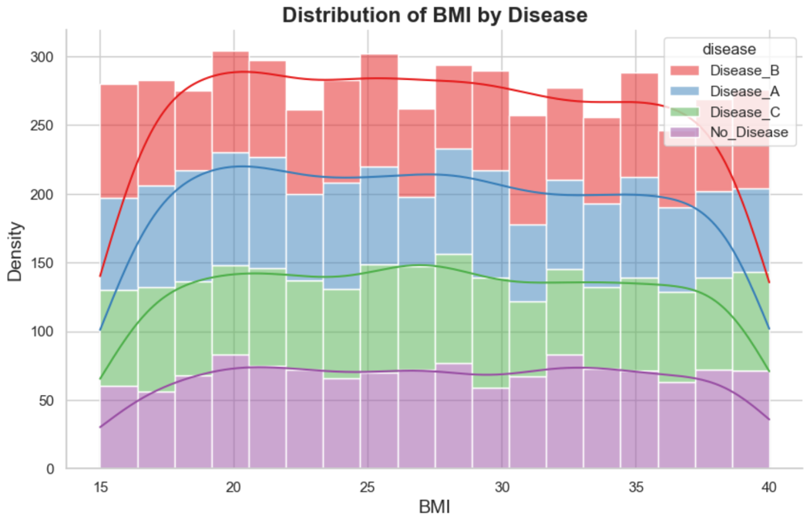

*Figure 7 Distribution of BMI by Disease*



*Figure 7.5 Distribution of BMI by Diseaser results*

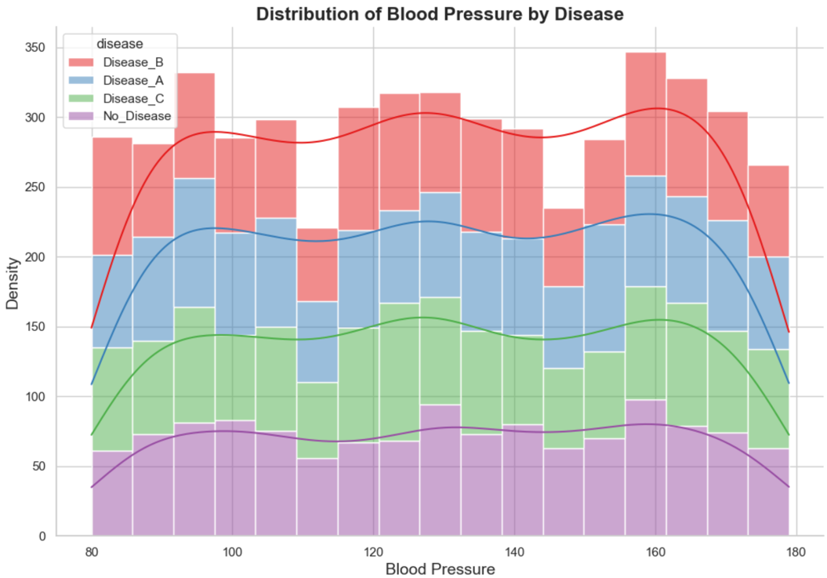

*Figure 8 Distribution of Blood Pressure by Disease*



*Figure 8.5 Distribution of Blood Pressure by Disease results*

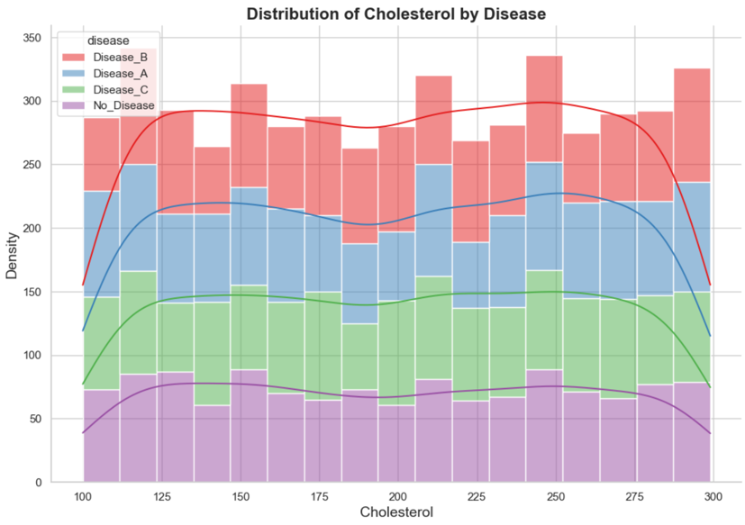

*Figure 9 Distribution of Cholesterol by Disease*



*Figure 9.5 Distribution of Cholesterol by Disease results*

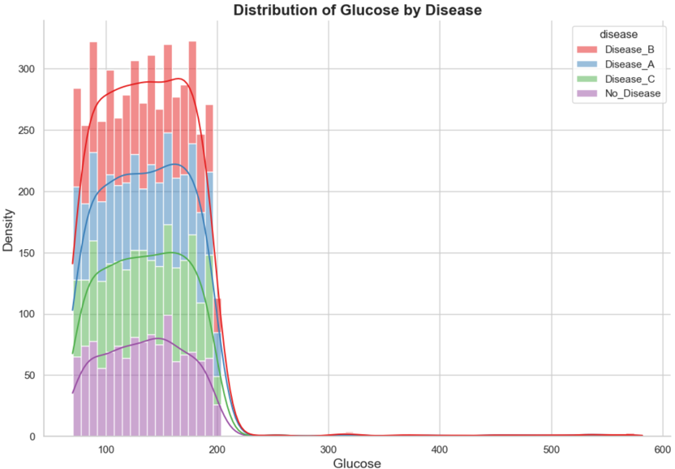

*Figure 10 Distribution of Glucose by Disease*



*Figure 10.5 Distribution of Glucose by Disease results*

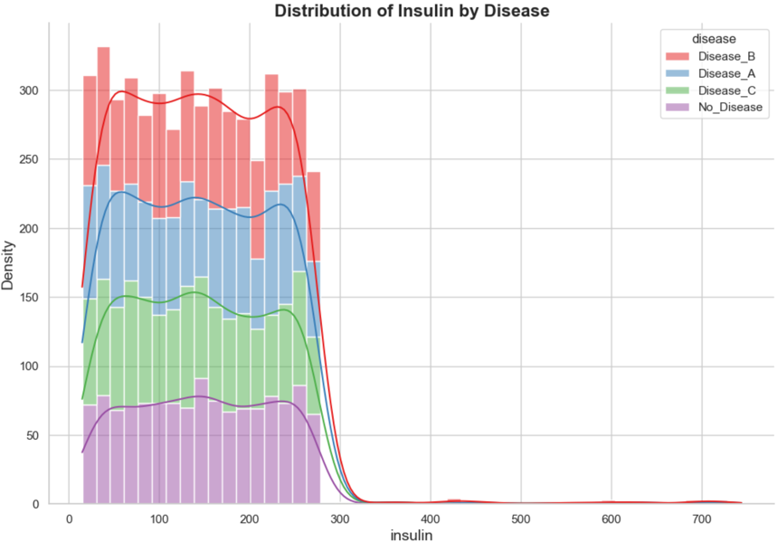

*Figure 11 Distribution of Insulin by Disease*



*Figure 11.5 Distribution of Insulin by Disease results*

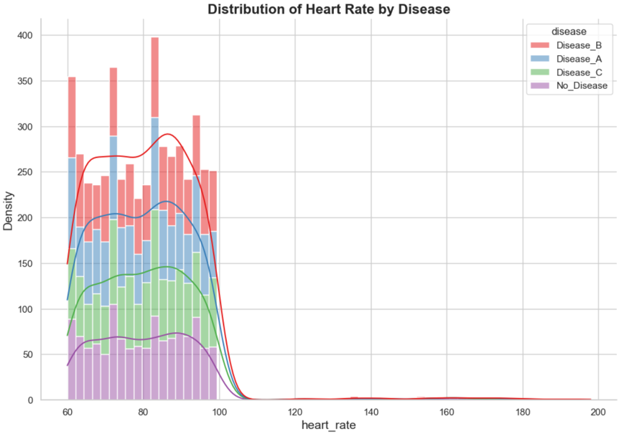

*Figure 12 Distribution of Heart Rate by Disease*



*Figure 12.5 Distribution of Heart Rate by Disease results*

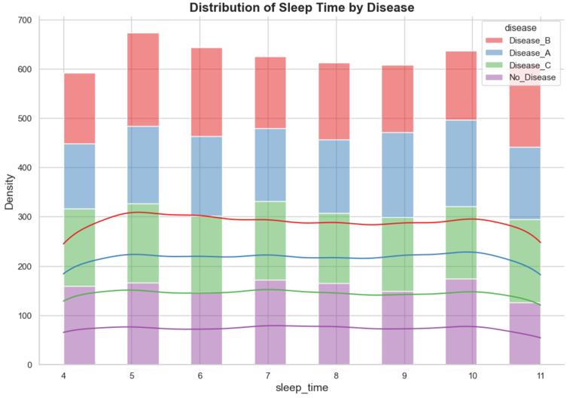

*Figure 13 Distribution of Sleep Time by Disease*



*Figure 13.5 Distribution of Sleep Time by Disease results*

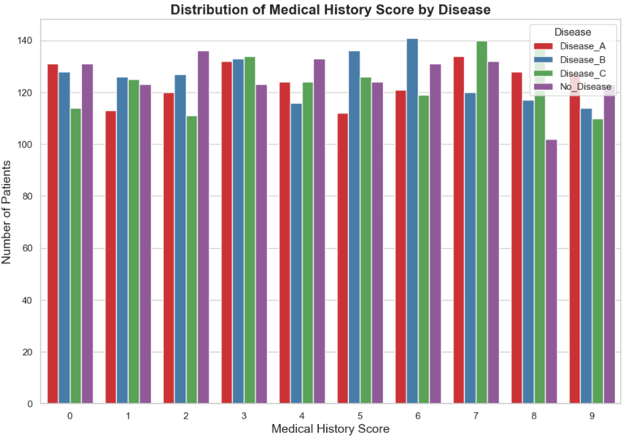

*Figure 13.5 Distribution of Medical History Score by Disease*



*Figure 13.5.2 Distribution of Medical History Score by Disease*

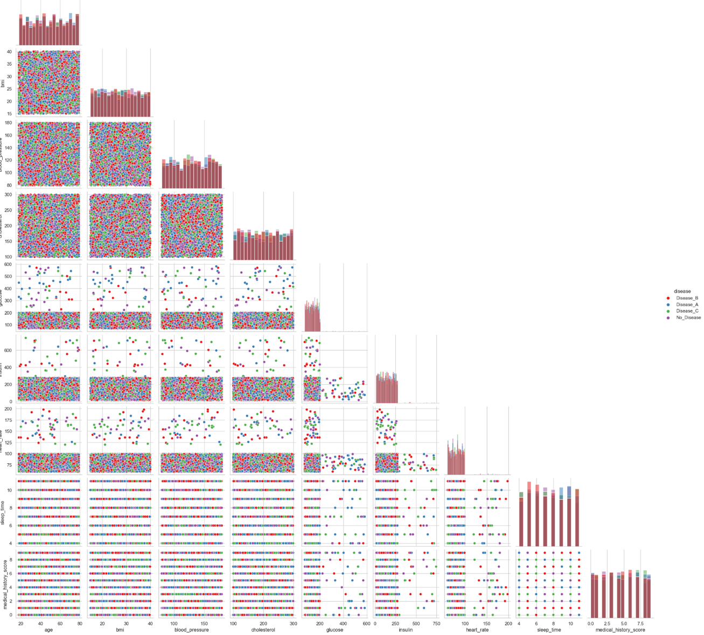

*Figure 14 Pair plot of Numerical Features by Disease*

I decided to use a pair plot with all the numerical features and include a histogram distribution as well so you don’t need to keep going back and look at the previous section (fig14). We can see that there are some weak correlations at best between the numerical features. The outliers were interesting to see, especially in insulin, glucose and heart rate.

I decided to replace the outliers through backfill in those three features. In figs 15-17 you can see the new distributions.

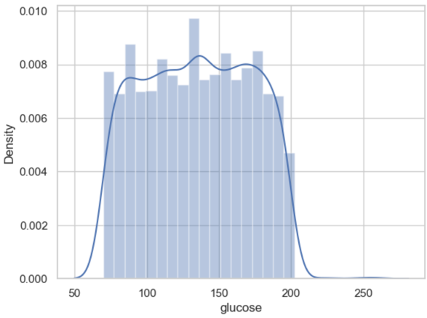

Figure 15 New Glucose Dist

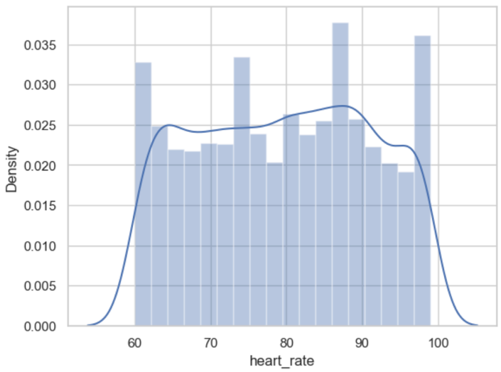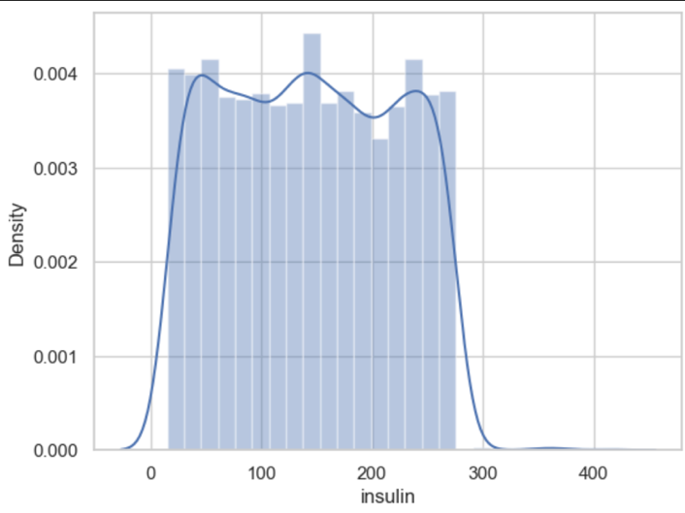

Figure 16 New Heart Rate Dist Figure 17 New Glucose Dist

In fig18 you can see the description of the stats of our categorical features. Some facts about our patients, most are smokers, have health insurance, do medium levels of exercise, have low income levels and stress levels and suffer from Disease B the most often.

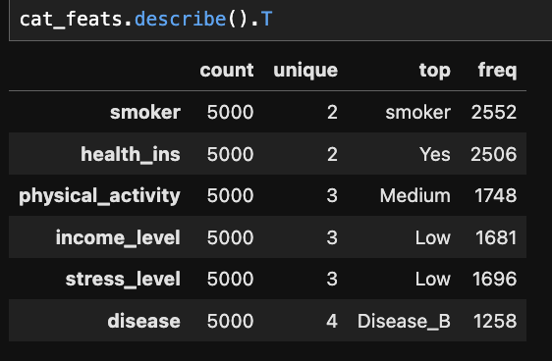

*Figure 18 Description of Categorical data*

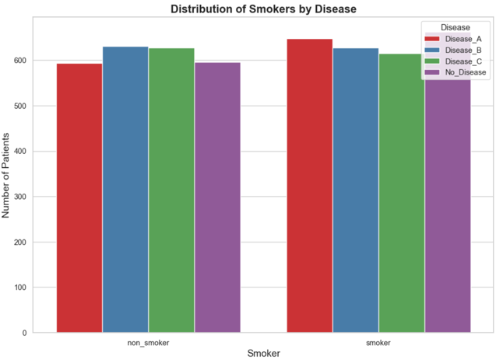

*Figure 19 Distribution of Sleep Time by Disease*



*Figure 19.5 Distribution of Sleep Time by Disease results*

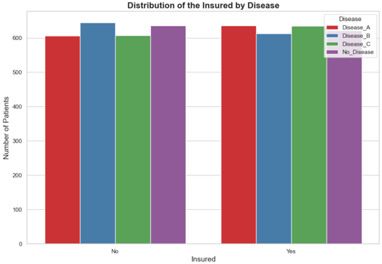

*Figure 20 Distribution of the Insured by Disease*



*Figure 20.5 Distribution of the Insured by Disease results*

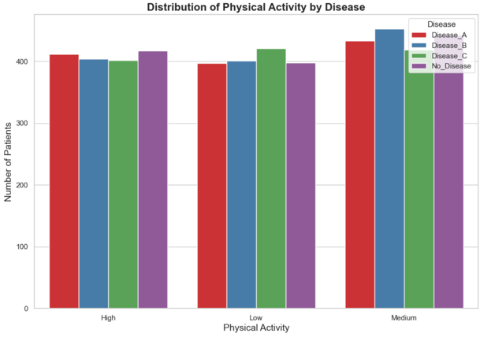

*Figure 21 Distribution of Physical Activity by Disease*



*Figure 21.5 Distribution of Physical Activity by Disease results*

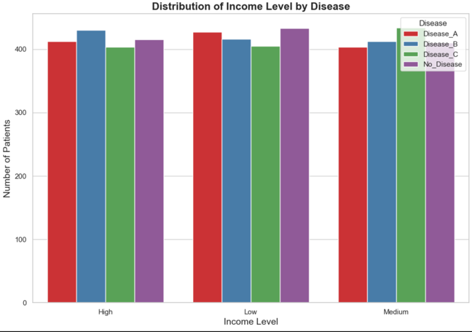

*Figure 22 Distribution of Income by Disease*



*Figure 22.5 Distribution of Income by Disease results*

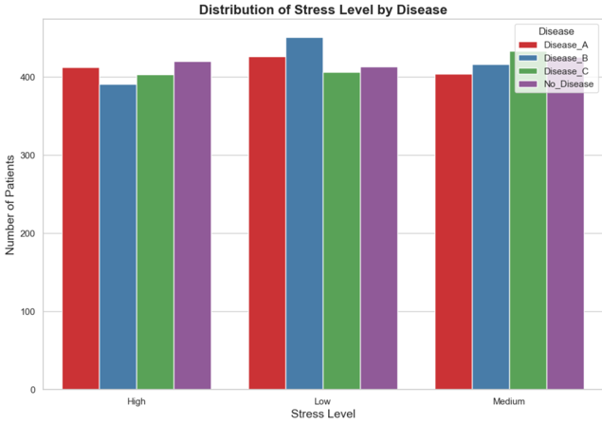

*Figure 23 Distribution of Stress Level by Disease*



*Figure 23.5 Distribution of Stress Level by Disease results*

## Encoding and Scaling

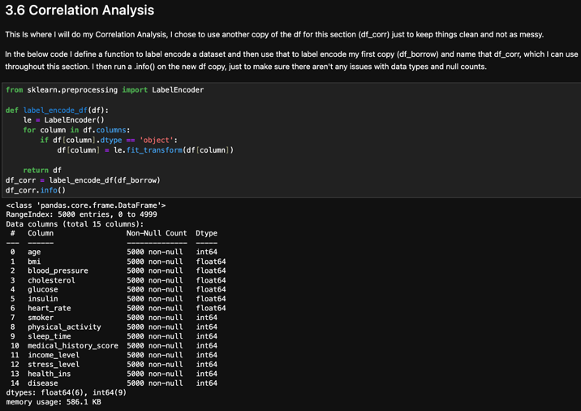

*Figure 24 Label encoding df_corr*

Here I am using a label encoding function to turn objects into numerical data for my correlation analysis. I do this and call it df_corr so I can use it exclusively for this section (fig24). This is to just keep things neat. I do the same for my categorical data later in my machine learning section which you can see in fig 25.5. Some scaling was also used during my PCA (fig25.5).

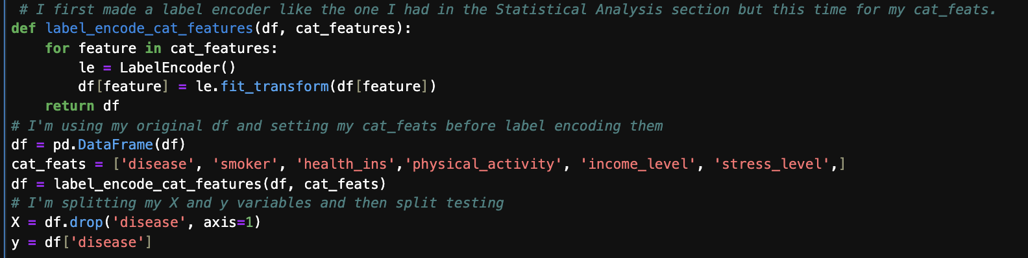

*Figure 25 Label encoding my Categorical Data.*

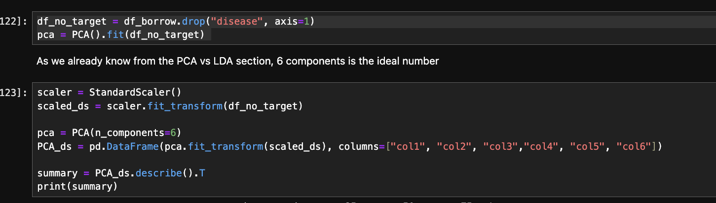

*Figure 25.5 Scaling of data during PCA*

## Dimension Reduction

I started with my PCA. I found the ideal number of components (fig 26). I then found the explained variance ratio of my components(fig27).

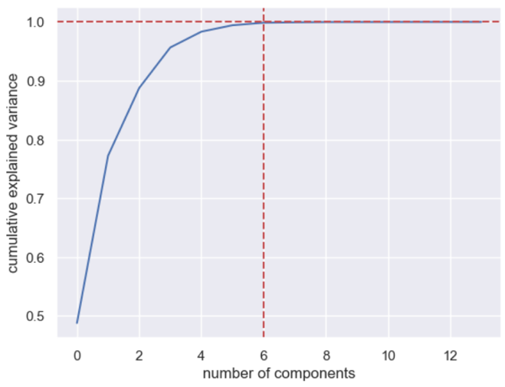

*Figure 26 Cumulative Explained Variance by Principal Component*

0 0.487878

1 0.284546

2 0.115169

3 0.068954

4 0.026886

5 0.010910

*Figure 27 explained variance ratio*

We can see that the first three components explain a majority of the data. After running the PCA’d data through some models I got the results seen in fig28. I also visualised it with a scatter plot using the first two components (fig29).

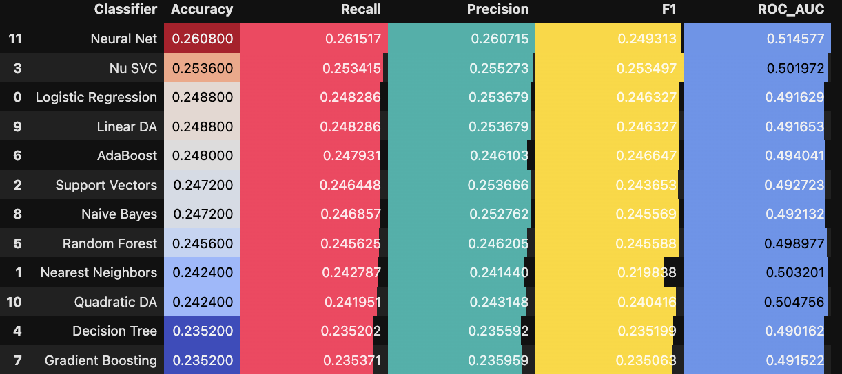

*Figure 28 Results of PCA data through classifiers*

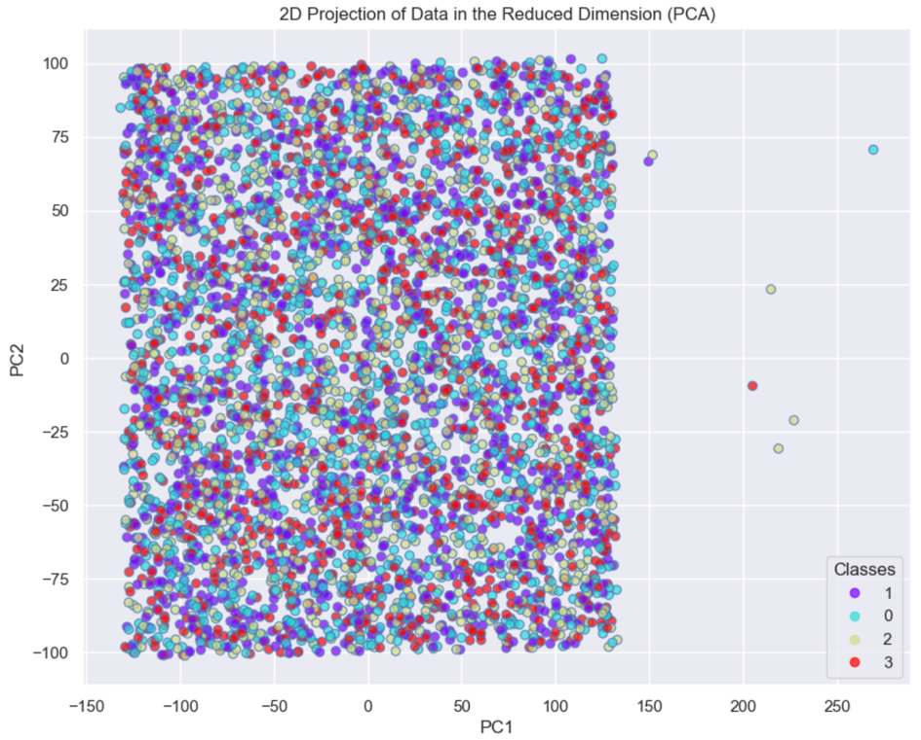

*Figure 29 Scatter plot of first 2 PCA components*

Next up was my LDA section which was split up into the four categories of the disease feature (fig30), and in figure 31 we can see that the first three components explain most of the variability in the data.

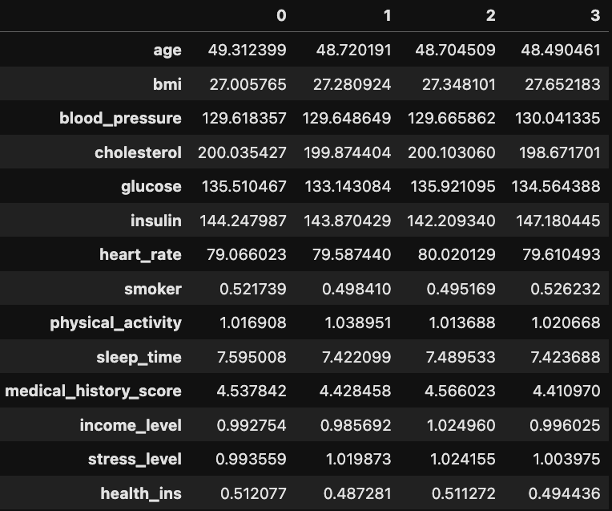 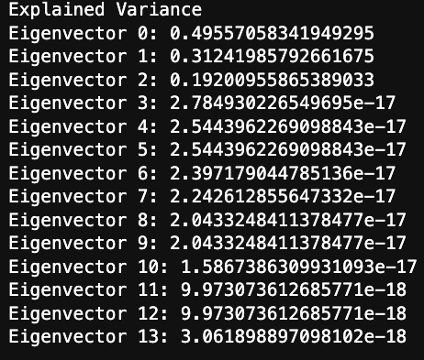

*Figure 30 LDA data Figure 31 Explained variance*

The results from the classifiers are seen in fig 32 and the visualisation on a 2DGraph can be seen in 33.

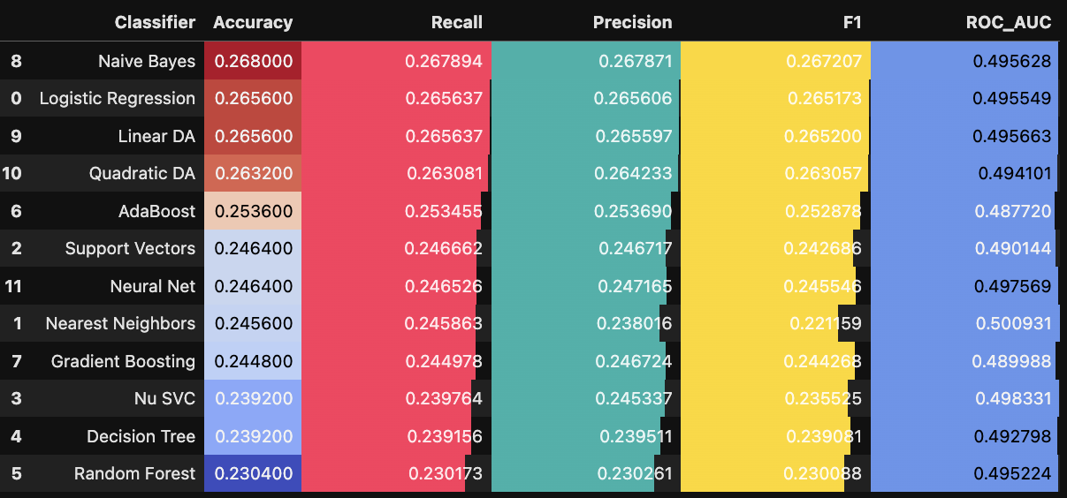

*Figure 32 Results of LDA data through classifiers*

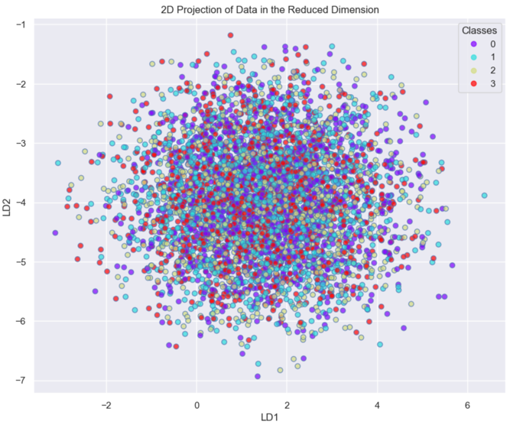

*Figure 33 Scatter plot of first 2 LDA components*

PCA is an unsupervised method that reduces dimensionality by maximizing the variance captured in a dataset (Chandra, 2013). It doesn't consider class labels, so the principal components are a result of overall data structure. On the other hand, LDA is a supervised method that reduces dimensionality by maximizing the separation between classes (Yang, 2018). It uses class labels to find linear discriminants that better separate the classes.

Both the PCA and LDA visualizations show significant overlap among classes, meaning that neither one achieves clear separation. The LDA way gives a slightly better separation if we had to choose, as it considers class labels, but the visual overlap and classifier performance mean that the dataset isn’t very good for classification. They both performed about the same with the classifiers neither one achieving 27%.

So while these two ways are effective at reducing dimensionality, it doesn’t help too much with this dataset.

# Stats 900

## Statistical Summary



*Figure 34 Statistical Description of Categorical Data*

**

*Figure 35 Statistical Description of Numerical Data*

Figs 34 & 35 show a statistical analysis of the numerical data, Figure 36 shows a summary of some of the key points. I have two *’s where I make claims about the patients. The first is BMI levels mean being 27.32 which indicates an overweight population of patients (Do Carmo et al., 2007). The second is Average blood pressure being 129.74 mmHg, showing borderline high levels (Brunström & Carlberg, 2018).

The visualisations for each feature can be seen in figures 4-23 in my EDA section *HERE**.*



*Figure 36 summary of key points*

## Tests

I started off with doing a a probability plot which showed the middle bit of my 'blood_pressure' data is approximately normally distributed (fig37).

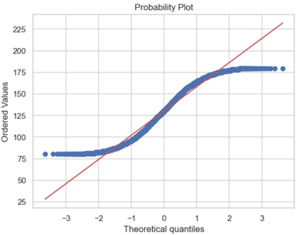

*Figure 37 Probability plot of blood_pressure feature*

Next I did an ANOVA test then a Levene’s test (Glass, 1966) which showed good homogeneity but the p value from the Shaprio test(Dudley, 2012) I did was far too low. I created some code to run the 3 test using the four categories from Disease and other metrics, but the results were just as useless as the p values were also all too low (fig38). Given these results, I decided to use the Kruskal-Wallis test (Cleophas & Zwinderman, 2016) as a non-parametric alternative to ANOVA, which does not assume normal distribution of the data. I got the following results, showing no significant differences in any metric between the categories (fig39), this is visually represented in figs 40-45.



*Figure 38 Results of ANOVA, Shaprio and Levene’s test*



*Figure 39 Results of Kruskal Wallis test*

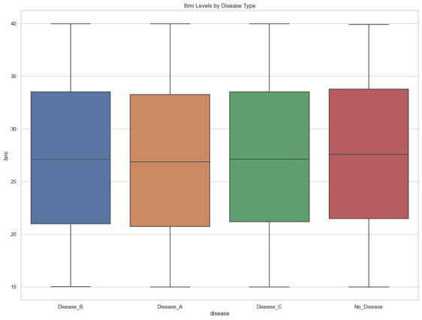 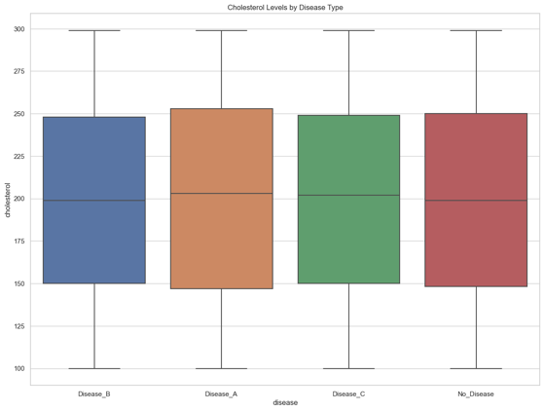

*Fig 40 KW test for BMI Fig 41 KW test for Cholesterol*

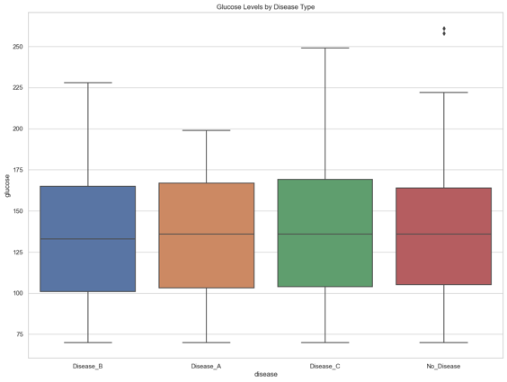 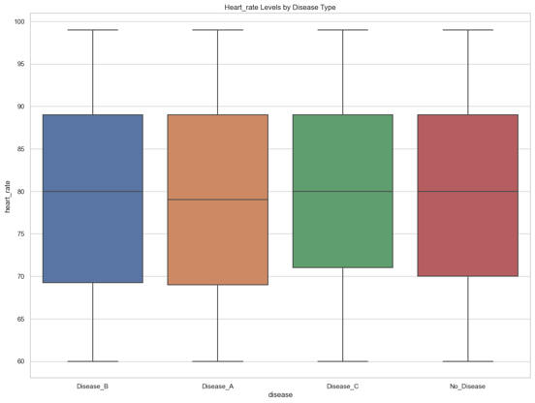

*Fig 42 KW test for Glucose Fig 43 KW test for Heart Rate*

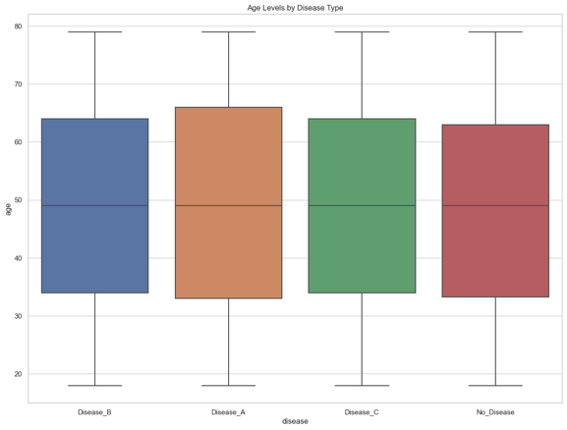 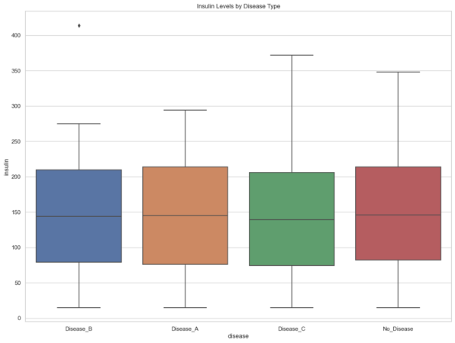

*Fig 44 KW test for Age Fig 45 KW test for Insulin*

Next was the T-tests on Blood Pressure for Disease A&B then C&D. Results are shown figs 46-48, but it’s basically the same problem with the ANOVA, the data isn’t normally distributed. So I found an alternative, the Mann Whitney U test (Wall Emerson, 2023). They both failed to reject the null hypothesis, and there were no significant differences in blood pressure and I would say the same for the other metrics too (fig49)

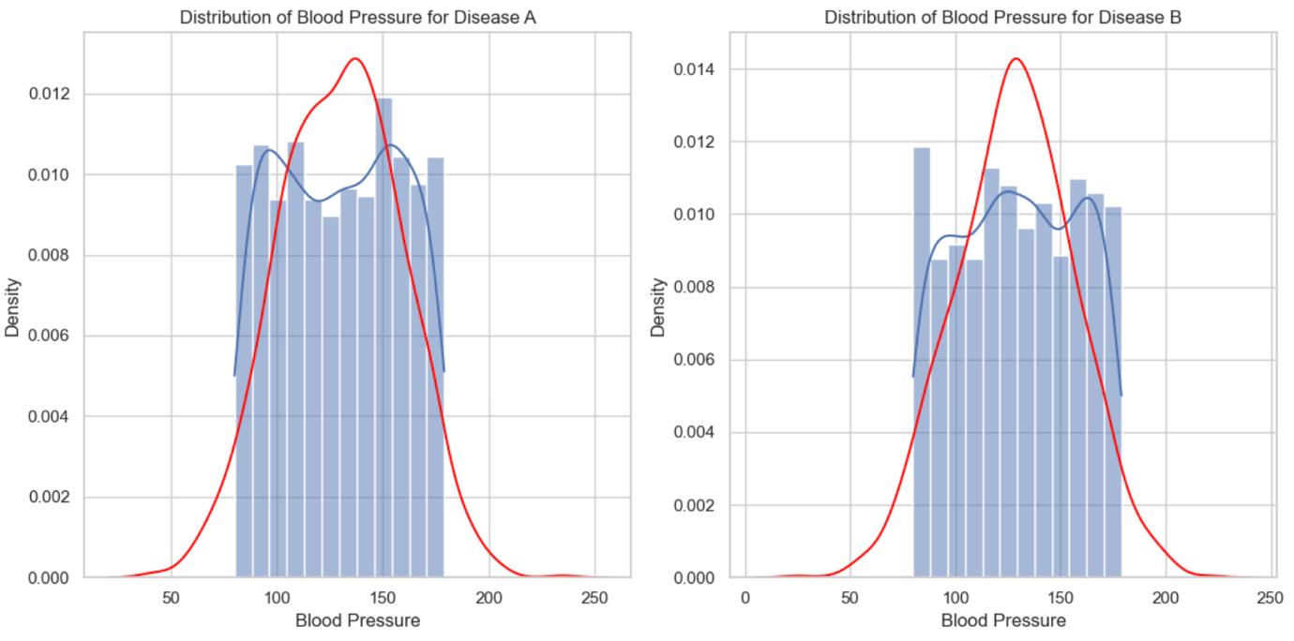

*Figure 46 Distribution of blood pressure for Diseases A & B*

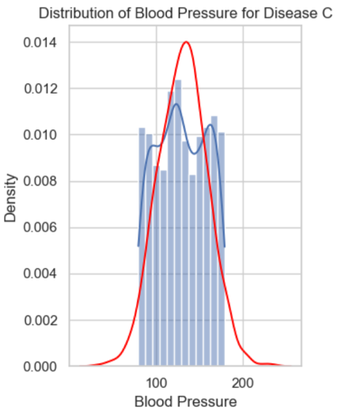 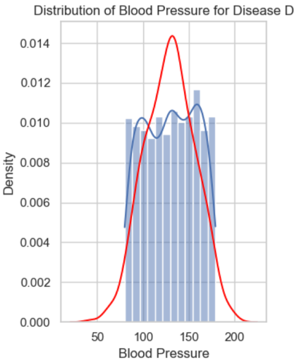

*Figure 47 & 48 Distribution of blood pressure for Diseases C & D*

**

*Figure 49 Results of the Mann Whitney U test*

Finally I used a Chi Squared test for my categorical data (Fienberg, 1979). I conducted the test on 5 pairs of features, each being a categorical feature and my disease column. I created blocks of code that work together to run all the tests at once, print the results (fig49)and visualise in the figures (fig50). To summarise, None of the categorical features showed a significant association with the disease based on the Chi-square tests, as all the p-values were greater than 0.05 (dotted red line in the visual)



*Figure 49 Chi Squared test results*

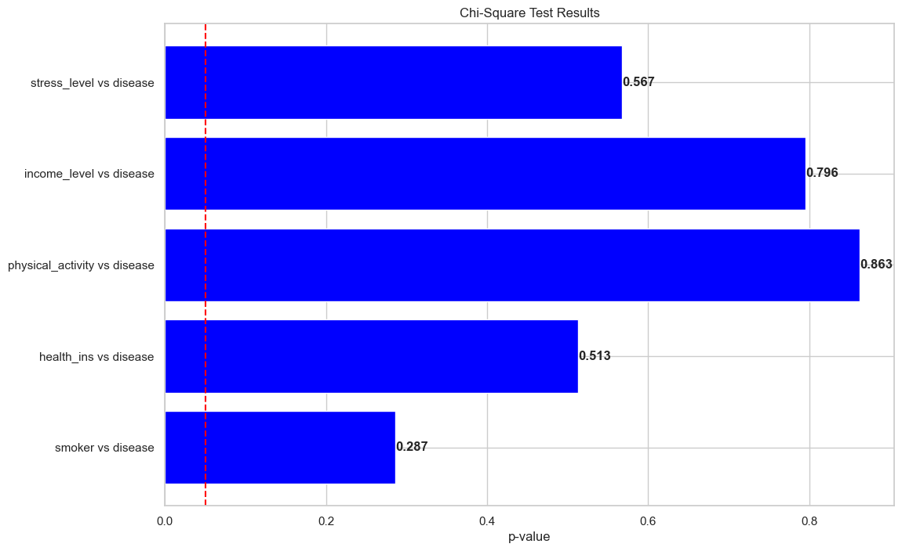

*Figure 50 Chi Squared test results visualisation*

## Correlation Analysis

I conducted a correlation analysis on the data. To do this I had to first label encode the categorical data but I used a copy of the dataset called df_corr. I began with a correlation matrix that showed how the other features correlated with our disease column(fig51). The results weren’t great but we could guess that based on our hypothesis test results.

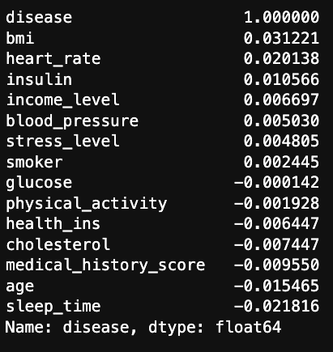

*Figure 51 Correlation matrix*

I then plotted this data on a bar plot, with bright distinguishing colours with Set1 (fig 52). I had to remove the disease column because it dwarfs the other features when it’s included.

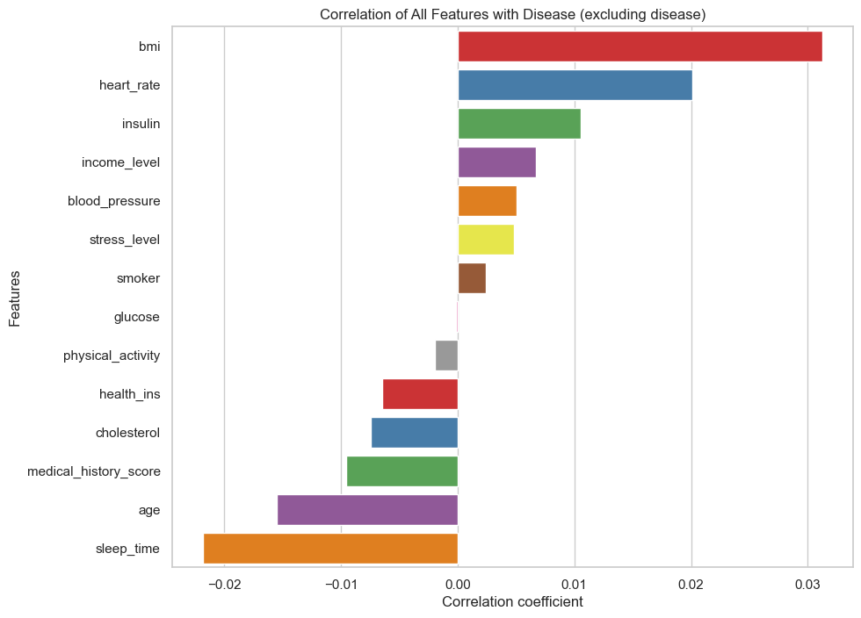

*Figure 52 Bar plot of correlation coefficients*

Finally I created heatmap to visualize the correlation matrix of numerical features using the Pearson's method (Rebekić et al., 2015). A mask is added to reduce redundant information and I added in some custom colours to try and distinguish the weak correlations better. Overall, we can identify and rank the variables with the largest positive and negative correlations, but the correlation analysis did not reveal any significant findings.

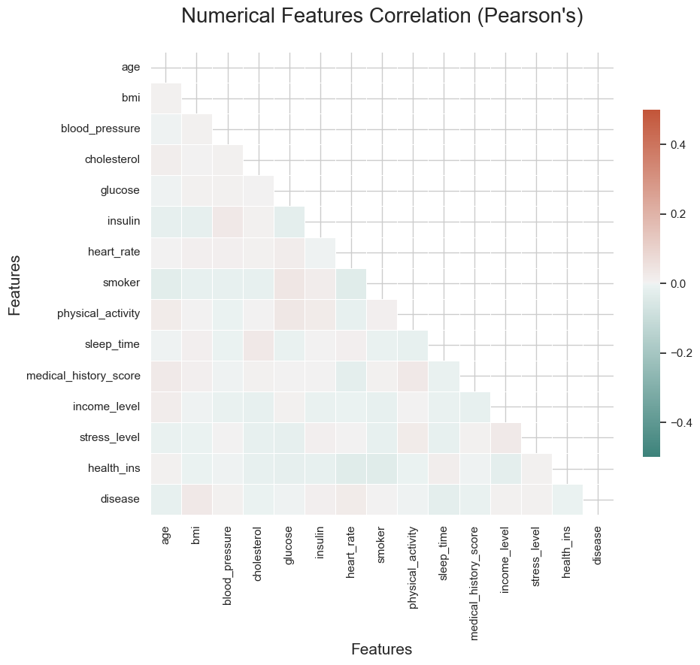

*Figure 53 Numerical features correlation*

# Machine Learning

Introduction

I decided to use a supervised classification model for predicting disease category and then an unsupervised k means clustering model for patient segmentation (Sinaga & Yang, 2020). I will go over objectives 1-3 from the brief for each method below and then a go over the results. I also did a PCA vs LCA which uses the same unsupervised techniques which I go over earlier in my report in my Dimension Reduction section HERE.

I used supervised models for classification to predict diseases because these models are designed to handle labelled data, which lets them learn the mapping between input features and known output categories. This way uses the labelled examples in my dataset, letting the models identify patterns and relationships between features and diseases or no disease, which leads to high predictive accuracy (Kotsiantis, 2007). Also, supervised models are well suited for tasks where the goal is to classify data into predefined categories based on learned patterns (Loog, 2018)

For patient segmentation, I used an unsupervised k-means clustering model because this method is best at finding groupings within the data without requiring prior knowledge of labels. K-means clustering identifies different segments of patients based on feature similarities, which helps in understanding patient heterogeneity and potentially revealing new subgroups within the patient population (Jain, 2010). This way is very valuable for exploratory analysis, as it uncovers underlying structures and patterns in the data that can inform further analysis and decision-making (Tan, Steinbach and Kumar, 2006).

## Supervised

I did a lot of research for this assignment, and during that research I came across a new technique to run multiple test on default parameters of multiple models at once testing accuracy, recall, precision, F1 and area under curve (Desalegn, 2023). I made some modifications in my later commits, where I removed NuSVC, as trying to run a grid search was taking far too long. I tried setting n_jobs-1 and I even bought a google collab pro subscription to try and run it (fig54). But with it being unfeasible with the time and hardware constraints I decided to take the model out. The models I did include can be seen in fig55.

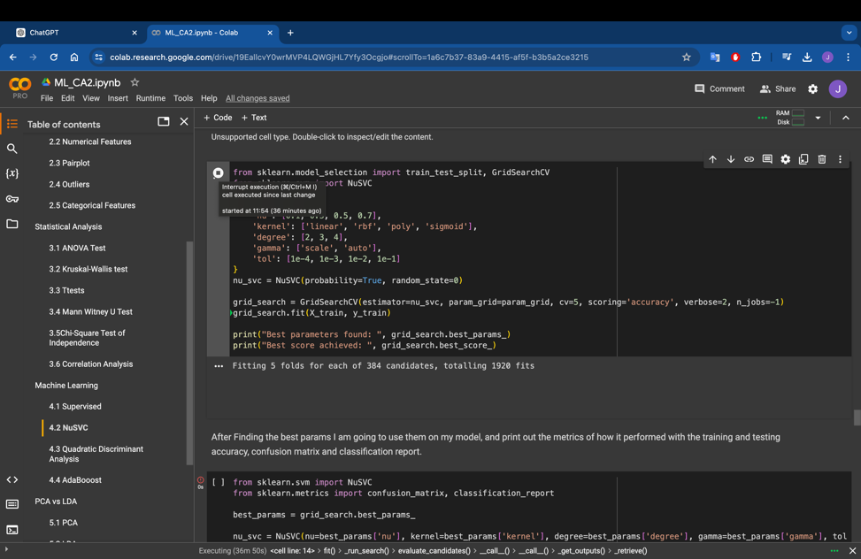

*Figure 54 Attempting to run code on google collab pro*

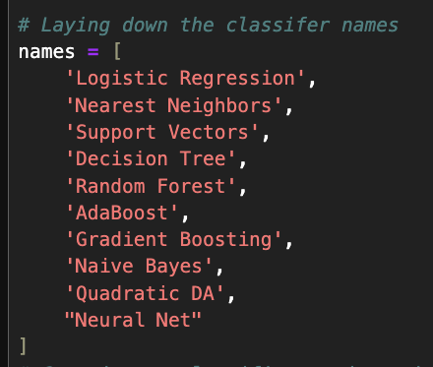

*Figure 55 Models used for testing*

The whole process worked like this:

I created a function to run my data on all the chosen classifiers. For each classifier I get them to:

- Fit the classifier to the training data

- predict on the validation set

- calculate performance metrics: accuracy, recall, precision, F1 score, and ROC AUC

- append the results to the list results

- visualise results in a table

This showed me which models performed the best on the dataset fig56.

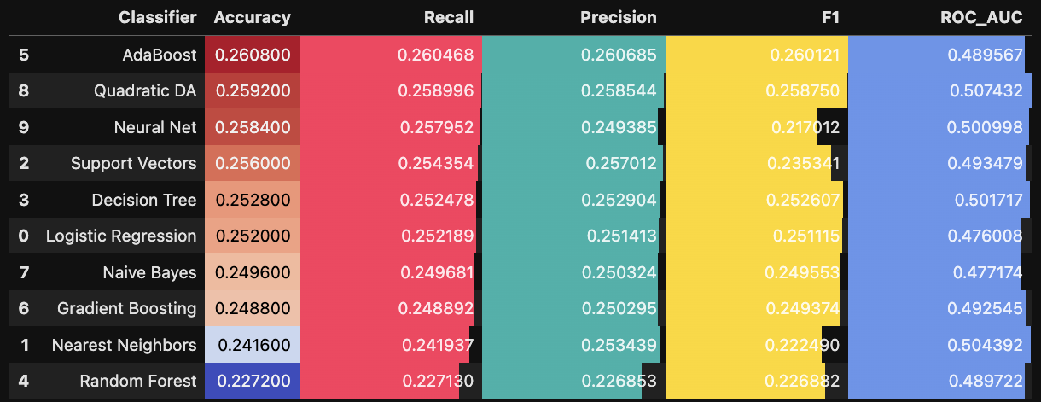

*Figure 55 Model performance*

I had to label encode my categorical features first, using only default parameters and used a .25 split with random state set at 0 for all classifiers.

I then began with the top three performing models. Fist was AdaBoost, I used a decision tree model as it’s base estimator, and the following hyperparameters as seen in fig56 (Balega & Azmi, 2020).

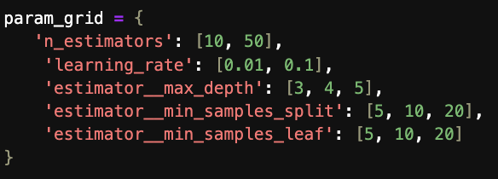

*Figure 56 Model 1 hyperparameters*

Second, after finding the best parameters I ran them through the classifiers, before thirdly running a K-Fold Cross-Validation with k=10, 20 and 30. I then created some code to do all three steps but on 5 different splits and got the following results (fig57).



*Figure 57 Results of Model 1*

We can see a lot of over fitting, especially in the first and fourth split. Increasing the number of folds didn’t significantly change the performances, and all confusion matrices show similar patterns of misclassifications across all three splits showing that the model's performance is stable but poor across different levels of cross-validation (Sjöberg, 2012).

For my second model, Quadratic Discriminate Analysis I used the following params in fig58. I conducted the same test and got the results in fig 59.

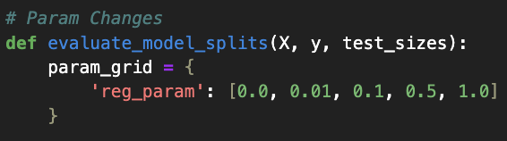

*Figure 58 Model 2 hyperparameters*



*Figure 59 Model 2 Results*

We can see a lot less over fitting in this model. But still the same as the last model, increasing the number of folds doesn’t significantly change the performances, and all of the confusion matrices show similar patterns of misclassifications across all three splits showing that the model's performance is stable but poor across different levels of cross-validation.

For my third model, I used a neural network. The model is uses the Adam optimizer (Choi et al., 2019) and employs the sparse categorical cross-entropy loss function. Its built with an input layer with 32 neurons and ReLU activation, a hidden layer with 16 neurons and ReLU activation, and an output layer with a number of neurons equal to the number of classes in the target variable (4), utilizing softmax activation. The results of this model can be seen in the fig60.



Figure 60 Model 3 results

We can see some underfitting in the models and then just like the previous models, increasing the number of folds doesn’t significantly change the performances, and all of the confusion matrices show similar patterns of misclassifications across all three splits showing that the model's performance is stable but poor across different levels of cross-validation.

Taking into consideration fitting, I would choose our neural network model with a .35 split if you wanted accuracy above all other metrics. But all the results are now there if any doctors wished to prioritise other metrics such as recall, precision or F1.

## Unsupervised

To address objective 2 I decided to use a K means clustering model to segment my patients (Kansal et al., 2018). I started off by reducing the dimensionality in my data through PCA. I then used the Elbow method to find the ideal number of clusters for my model (Kodinariya, 2013) which you can see in fig 61.

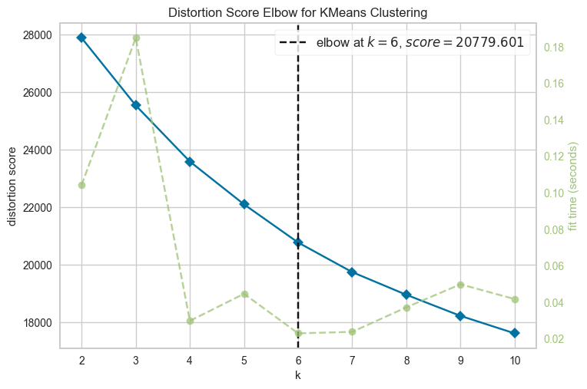

*Figure 61 Elbow method*

I then used a 3D scatter plot using the first three principal components as the x, y, and z coordinates, and coloured the points based on their cluster. As you can see in fig62, they are very mixed together and overlap a lot, showing no clear separation.

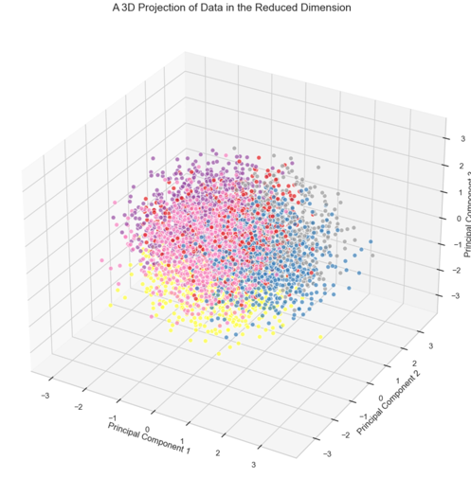

*Figure 62 3D Scatter plot of my clusters*

In fig 62.5, you can see that the distribution of the clusters is very balanced.

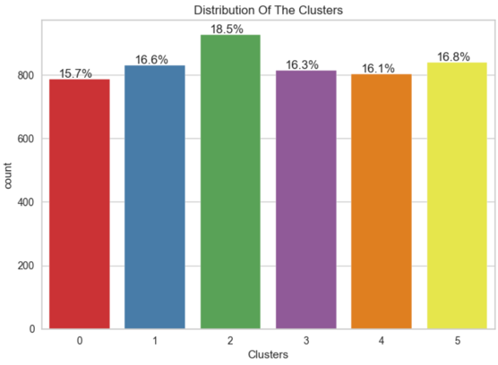

*Figure 62.5 Bar plot of my clusters*

I then began to conduct EDA on the clusters to see if we can single out any characteristics or behaviours. These can be seen in figs 63 to 68 where two features are plotted with the clusters as the points.

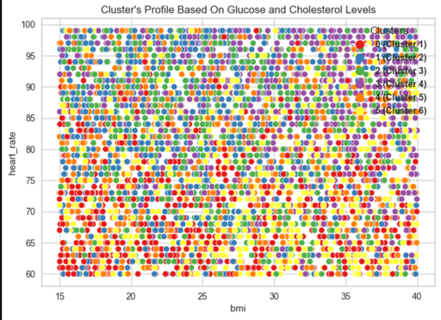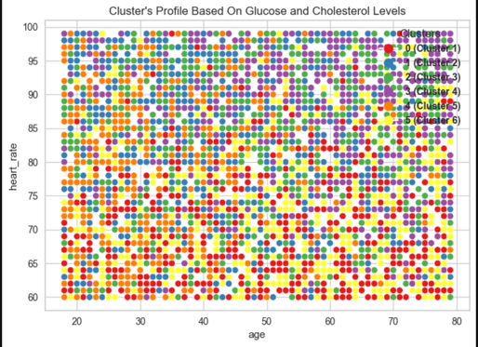

*Figure 63 BMI vs Heart Rate Figure 64 Heart Rate vs Age* 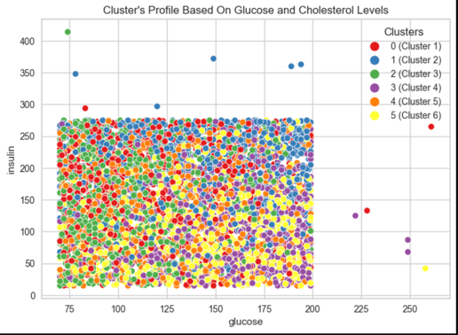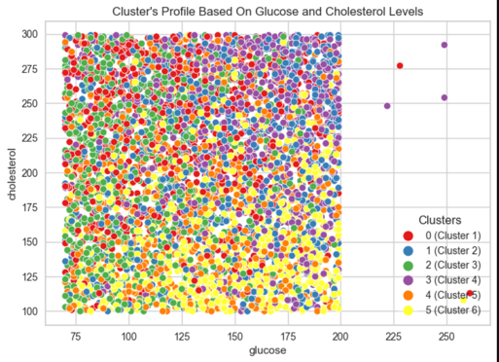

*Figure 65 Insulin vs Glucose Figure 66 Cholesterol vs Glucose*

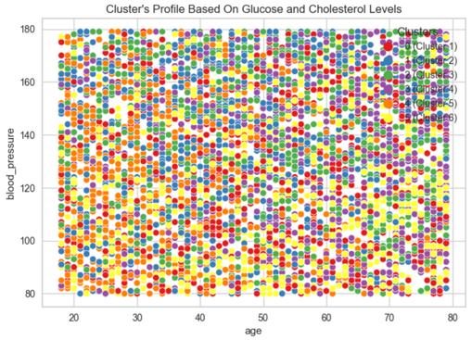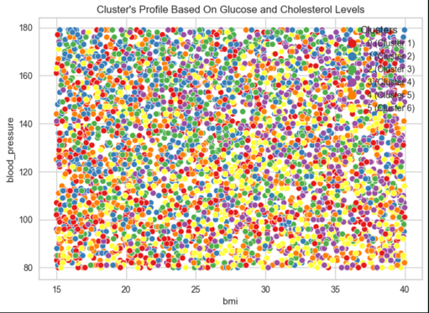

*Figure 67 Blood Pressure vs Age Figure 68 67 Blood Pressure vs Age*

As you can see from the plots, there’s not much that can be taken from these clusters, as there are no clear groupings or correlations of the clusters.

# Conclusion and Key Findings

The objectives of this report were twofold. First, I tried to predict the presence of Disease A, B, C, or none in a patient. I successfully created 3 different classifiers with 5 splits, 3 different fold validations, and applied a grid search to optimize our neural network model for accuracy, considering fitting. On the other hand, my findings showed very poor scores for our classification model, suggesting that more data features and samples are needed to improve accuracy. Secondly, I tried to create patient segments for further analysis. I used PCA’d data in a k-means clustering model, using the elbow method to create six clusters of patients. My analysis revealed no distinct groupings or correlations within the clusters, indicating that the data does not exhibit clear patterns that can be easily categorized or interpreted through clustering techniques.

*Key Findings*

From my hypothesis tests, I saw that the data is very homogenous, with no significant differences in any metric between the disease categories. My EDA showed that the data is not normally distributed. Correlation analysis showed that any correlations with the disease columns are very weak. From my statistical summary, I gained insights into the patient population and their characteristics. In relation to the objectives, all models returned very weak results even with parameter tuning, and my clustering showed no distinct groups. This suggests that the data itself requires more work, including more features and samples.

*Limitations*

One limitation of this study is the impact of the clustering algorithm's parameters on the results. Future research could explore different algorithms or parameter settings to determine if more meaningful clusters can be identified. Another limitation is time, as this assessment has a deadline. Additionally, computing power was a problem, for example, my computer couldn’t run the NuSVC classifier which I mentioned earlier. The lack of domain expertise or access to a medical expert to provide insight and direction was also a limitation.

*Future Research*

Further research should consider expanding the dataset before conducting analyses. Alternative methods of data analysis, such as more advanced machine learning techniques, should be explored to try find hidden patterns that clustering might have missed.

In conclusion, while clustering did not reveal distinct groupings in this dataset and classifiers did not return impactful scores, the findings provide a foundation for future investigations into more appropriate analytical methods.

# References

**Word Count - 3148 excluding titles, figures and references**

**GitHub - https://github.com/CCT-Dublin/inetgrated-ca2-dp-stda-and-ml-2024200**

Balega, S. and Azmi, S.S. (2020) ‘An Overview of Boosting Decision Tree Algorithms utilizing AdaBoost and XGBoost Boosting strategies’, International Research Journal of Engineering and Technology (IRJET), 7(5). doi:10.1109/access.2020.2988796.

Loog, M. (2018) ‘Supervised classification: Quite a brief overview’, *Machine Learning Techniques for Space Weather*, pp. 113–145. doi:10.1016/b978-0-12-811788-0.00005-6.

Brunström, M. and Carlberg, B. (2018) ‘Association of blood pressure lowering with mortality and cardiovascular disease across blood pressure levels’, JAMA Internal Medicine, 178(1), p. 28. doi:10.1001/jamainternmed.2017.6015.

Chandra, P.L. (2013) ‘Methodological Analysis of Principal Component Analysis (PCA) Method’, M International Journal of Computational Engineering & Management, 16(2), p. 32. Available at: https://citeseerx.ist.psu.edu/document?repid=rep1&type=pdf&doi=6f5c37562374b9053d8212d7c97bbdd68cee2133 (Accessed: 23 May 2024).

Choi, D., Shallue, C.J., Nado, Z., Lee, J., Maddison, C.J., and Dahl, G.E. (2019) ‘On Empirical Comparisons of Optimizers for Deep Learning’, arXiv preprint arXiv:1910.05446. Available at: https://arxiv.org/abs/1910.05446 [Accessed 24 May 2024].

Cleophas, T.J. and Zwinderman, A.H. (2016) ‘Non-parametric Tests for Three or More Samples (Friedman and Kruskal-Wallis)’, in Clinical Data Analysis on a Pocket Calculator. Springer, Cham.

Desalegn, G. (2023) Heart Disease Predictions, Kaggle. Available at: https://www.kaggle.com/code/desalegngeb/heart-disease-predictions/notebook (Accessed: 24 May 2024).

Do Carmo, I. et al. (2007) ‘Overweight and obesity in Portugal: National prevalence in 2003–2005’, Obesity Reviews, 9(1), pp. 11–19. doi:10.1111/j.1467-789x.2007.00422.x.

Dudley, R. (2012) THE SHAPIRO–WILK TEST FOR NORMALITY [Preprint]. doi: https://math.mit.edu/~rmd/46512/shapiro.pdf.

Fienberg, S.E. (1979) ‘The use of chi-squared statistics for Categorical Data Problems’, Journal of the Royal Statistical Society Series B: Statistical Methodology, 41(1), pp. 54–64. doi:10.1111/j.2517-6161.1979.tb01057.x.

Glass, G.V. (1966) ‘Testing homogeneity of variances’, American Educational Research Journal, 3(3), pp. 187–190. doi:10.3102/00028312003003187.

Jain, A.K. (2010) ‘Data clustering: 50 years beyond K-means’, *Pattern Recognition Letters*, 31(8), pp. 651-666.

Kansal, T. et al. (2018) ‘Customer segmentation using K-means clustering’, 2018 International Conference on Computational Techniques, Electronics and Mechanical Systems (CTEMS) [Preprint]. doi:10.1109/ctems.2018.8769171.

Kodinariya, T.M. (2013) International Journal of Advance Research in Computer Science and Management Studies, 1(6), p. 92. doi:10.61161/ijarcsms.

Kotsiantis, S.B. (2007) ‘Supervised Machine Learning: A Review of Classification Techniques’, *Informatica*, 31(3), pp. 249-268. Available at: <https://www.informatica.si/index.php/informatica/article/view/148/140>

Leino, M. (2016) Coding Standards in Web Development, N/A. Available at: https://www.theseus.fi/bitstream/handle/10024/112473/leino_martti.pdf?sequence=1 (Accessed: 23 May 2024).

Rebekić, A. et al. (2015) ‘Pearson’s or Spearman’s correlation coefficient - which one to use?’, Poljoprivreda, 21(2), pp. 47–54. doi:10.18047/poljo.21.2.8.

Sinaga, K.P. and Yang, M.-S. (2020) ‘Unsupervised K-means clustering algorithm’, IEEE Access, 8, pp. 80716–80727. doi:10.1109/access.2020.2988796.

Tan, P.-N., Steinbach, M. and Kumar, V. (2006) *Introduction to Data Mining*. Boston: Addison-Wesley. Pg125

Sjöberg, D. (2012) ‘Nonlinear System Identification Using Deep Learning Networks’, in Proceedings of the 20th European Symposium on Artificial Neural Networks, Computational Intelligence and Machine Learning (ESANN 2012), Bruges, Belgium, 25-27 April 2012. Available at: https://www.esann.org/sites/default/files/proceedings/legacy/es2012-62.pdf (Accessed: 24 May 2024).

Wall Emerson, R. (2023) ‘Mann-Whitney U test and t-test’, Journal of Visual Impairment & Blindness, 117(1), pp. 99–100. doi:10.1177/0145482x221150592.

Yang, J. (2018) An Efficient LDA Algorithm for Face Recognition, PDF. Available at: https://citeseerx.ist.psu.edu/document?repid=rep1&type=pdf&doi=30c7c01cce3630f55195cf14a27ea20d2c143bb8 (Accessed: 23 May 2024).